CASE FILE 07
Shellshock Cases
Product line: phone cases
Shellshock sells phone cases online and at mall kiosks. They have 40 designs but no plan, and the owners want to rebuild the lineup around who actually buys cases.
Your job: Build a lineup of three versions, one for each segment below. For every version, choose its features and set its price. Your goal is the most total profit across all three.
THE MARKET: THREE SEGMENTS
Shellshock Cases surveyed people in the Chicago area. The survey split them into three groups. Read the profiles, then give each segment a name.
SEGMENT A  18,000 potential customers | SEGMENT B  12,000 potential customers | SEGMENT C  4,000 potential customers
- Ages 13 to 25, buys 3 or more cases a year  - Matches the case to outfits or seasons  - Finds new cases on social media  “My case is an accessory, not armor.” | - All ages, has cracked a screen in the last 2 years  - Paid $150 or more for a screen repair  - Buys one case and keeps it until it falls apart  “I have dropped my phone in a lake. Twice.” | - Ages 20 to 55, works construction or outdoors  - Uses the phone in rain, dust, and mud  - Needs the phone on their hip, not in a pocket  “If it can't survive a job site, I don't want it.”
Our name for them: | Our name for them: | Our name for them:
PRODUCT BASICS
Base cost of every version | $3 per case, before any features are added
Price options | $12 $20 $30 $45 $60 $80 (each version must use one of these prices)
WARM-UP: READ THE DATA FIRST
1. Which segment has the most must-have features (60% or higher)? How many does it have?

2. What is the most expensive feature on the menu? Which segment, if any, says it is a must-have?

3. What is the lowest price at which fewer than half of Segment B would buy?

4. If Shellshock Cases sold a version with a Fit of 100% to Segment A at $20, how many people would buy it?

SURVEY RESULTS: WHAT EACH SEGMENT REQUIRES
Question asked: “Which of these would a phone case need to have before you would buy it?”
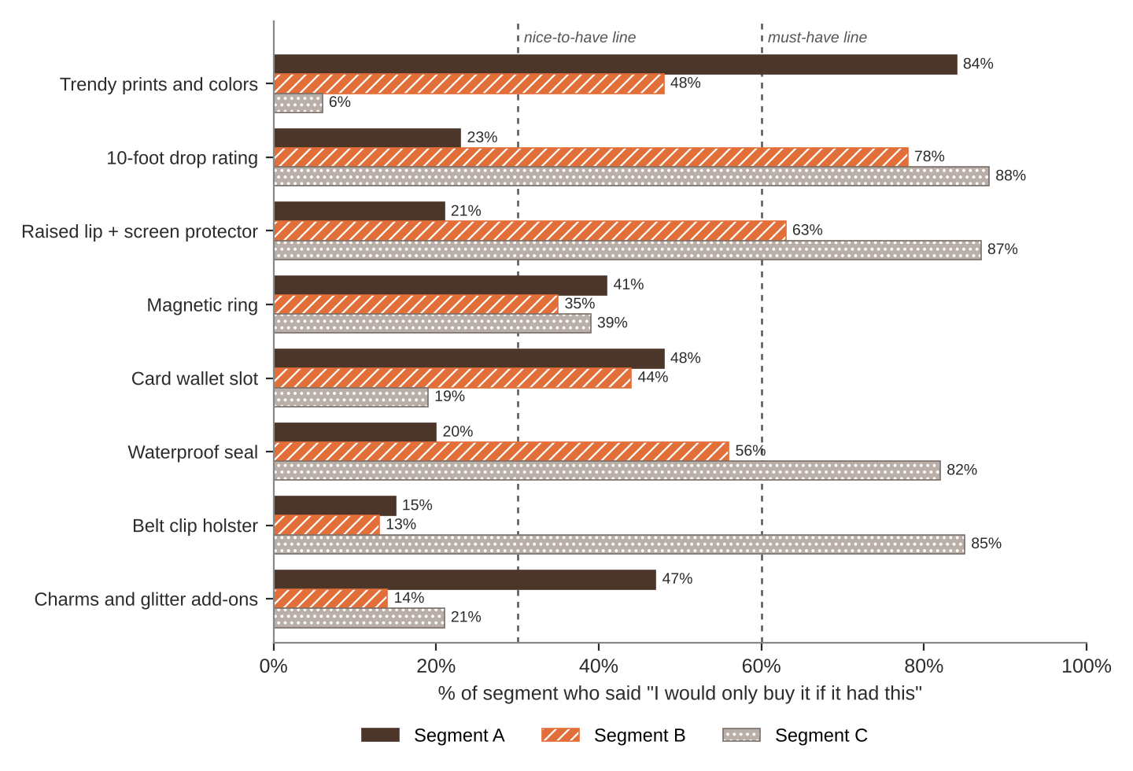
FEATURE MENU
Every feature you add raises your cost per case. Add a feature to any version you want.
Feature | What it is | Cost to add
Trendy prints and colors | New designs every month | $1
10-foot drop rating | Tested to survive a 10-foot fall | $4
Raised lip + screen protector | Screen never touches the ground | $2
Magnetic ring | Snaps onto chargers and car mounts | $3
Card wallet slot | Holds an ID and two cards | $1.50
Waterproof seal | Fully sealed against water and dust | $8
Belt clip holster | Wear the phone on your belt | $3
Charms and glitter add-ons | Clip-on charms and sparkle finish | $1
SURVEY RESULTS: WHAT EACH SEGMENT WILL PAY
Question asked: “If it had everything you need, would you buy it at this price?”
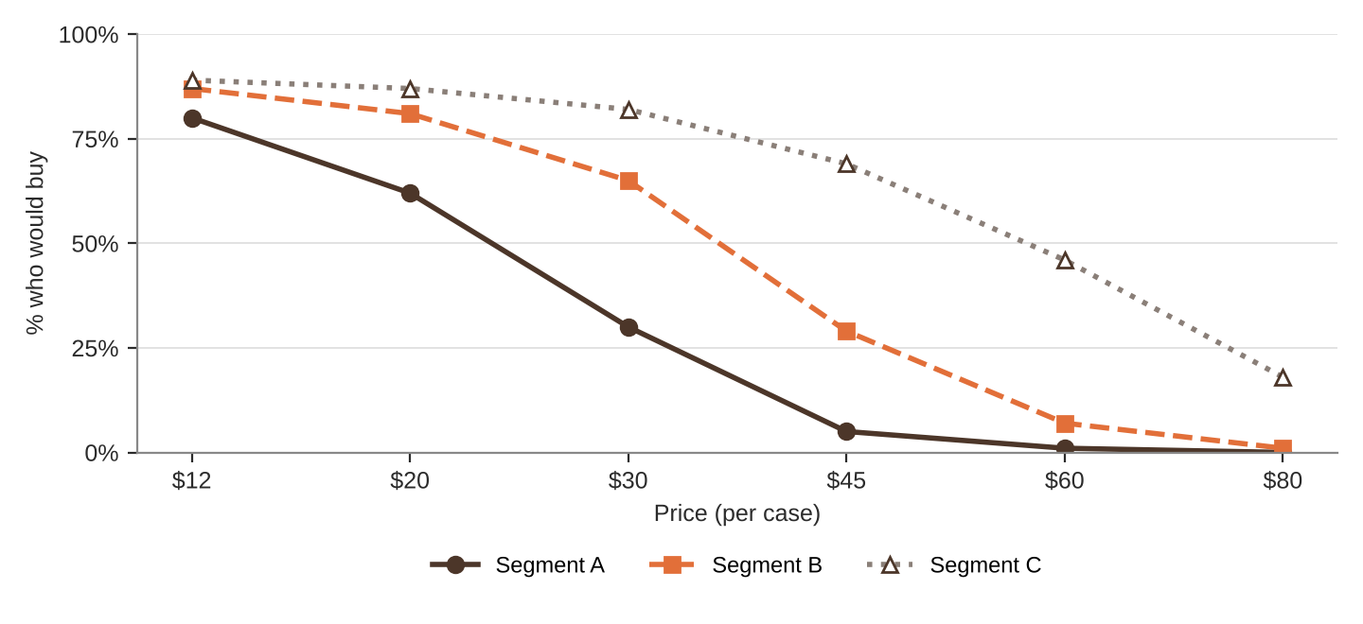
% of each segment who would buy at each price
Price | $12 | $20 | $30 | $45 | $60 | $80
Segment A | 80% | 62% | 30% | 5% | 1% | 0%
Segment B | 87% | 81% | 65% | 29% | 7% | 1%
Segment C | 89% | 87% | 82% | 69% | 46% | 18%
QUICK RULES
Must-have | A feature that 60% or more of a segment requires. Leave one out and that segment's buyers are cut in half. Leave two out and they're cut in half again.
Nice-to-have | A feature that 30% to 59% of a segment requires. Each one you include adds 5% to Fit.
Under 30% | That segment doesn't care. It adds cost and nothing else.
Fit | Start at 100%. Add 5% for each nice-to-have included. Then cut in half for each must-have left out.
Buyers | Segment size × % who would buy at your price × Fit. Round to a whole number.
Profit | Buyers × (Price − Unit cost). Unit cost = base cost + cost of every feature you added.

